Bayesian Research Project

Kevin Choi

2022-04-28

# Research Question

Is there a difference in how people imagine the future self when they are primed to think about the self as stable or changeable?

# Variables

* Vividness: subjective rating of the vividness of the imagined future self (2 items on a 6 point scale averaged)
* Connectedness: subjective rating of the perceived connectedness of the imagined future self (2 items on a 6 point scale averaged)
* Distance: subjective rating of the temporal distance of the imagined future self (2 items on a 6 point scale averaged)
* Relevance: subjective rating of how relevant the imagined future self feels (2 items on a 6 point scale averaged)
* Condition: 1 = self-stability, 2 = self-change

## Import Data

data <- read_sav("data.sav")

## Variable Summary

#Data  
# describe(data)  
  
##Summary Statistics for Variables of Interest   
describeBy(data.frame(data$VIVD, data$CONNECT, data$DIST, data$RELEVANCE), data$COND)

##   
## Descriptive statistics by group   
## group: 1  
## vars n mean sd median trimmed mad min max range skew  
## data.VIVD 1 138 3.39 0.42 3.5 3.39 0.00 2.5 4.5 2.0 0.04  
## data.CONNECT 2 138 3.85 0.55 4.0 3.84 0.74 2.0 5.0 3.0 0.11  
## data.DIST 3 138 3.62 0.45 3.5 3.60 0.74 2.5 5.0 2.5 0.47  
## data.RELEVANCE 4 138 3.66 0.57 3.5 3.61 0.74 1.5 6.0 4.5 0.72  
## kurtosis se  
## data.VIVD 0.42 0.04  
## data.CONNECT 0.08 0.05  
## data.DIST 0.76 0.04  
## data.RELEVANCE 3.20 0.05  
## ------------------------------------------------------------   
## group: 2  
## vars n mean sd median trimmed mad min max range skew  
## data.VIVD 1 142 3.39 0.51 3.5 3.39 0.74 2.0 5.0 3 0.13  
## data.CONNECT 2 142 3.79 0.55 3.5 3.78 0.74 2.5 5.5 3 0.34  
## data.DIST 3 142 3.54 0.52 3.5 3.57 0.74 2.0 5.0 3 -0.50  
## data.RELEVANCE 4 142 3.56 0.52 3.5 3.55 0.00 1.0 5.0 4 -0.41  
## kurtosis se  
## data.VIVD 0.42 0.04  
## data.CONNECT 0.10 0.05  
## data.DIST 0.81 0.04  
## data.RELEVANCE 3.91 0.04

##Correlation Matrix   
source("http://www.sthda.com/upload/rquery_cormat.r")  
#Combined   
rquery.cormat(data[c("VIVD","CONNECT","DIST","RELEVANCE")], type="flatten")

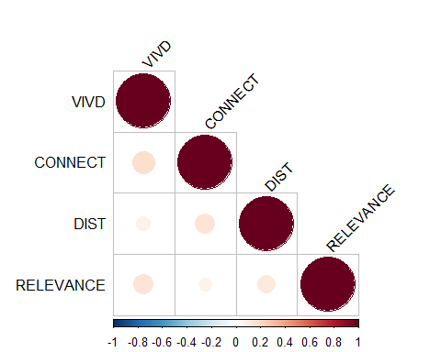

## $r  
## row column cor p  
## 1 VIVD CONNECT 0.170 0.0039  
## 2 VIVD DIST 0.075 0.2100  
## 3 CONNECT DIST 0.140 0.0230  
## 4 VIVD RELEVANCE 0.140 0.0200  
## 5 CONNECT RELEVANCE 0.064 0.2900  
## 6 DIST RELEVANCE 0.110 0.0710  
##   
## $p  
## NULL  
##   
## $sym  
## NULL

#By Condition  
data.short <- data[c("COND","VIVD","CONNECT","DIST","RELEVANCE")]  
  
  
#Exploratory Factor Analysis

# Model

Let $Y$ = VIVIDNESS, CONNECTION, TEMPORAL DISTNACE, & RELEVANCE, $G$ = CONDITION (CONTINUITY v CHANGE)

Model:

$$\begin{matrix}Y_{i,G=0} & ∼N\left(μ_{1},σ_{1}\right) \\ Y_{i,G=1} & ∼N\left(μ_{2},σ_{2}\right)\end{matrix}$$

Prior:

$$\begin{matrix}μ_{1} & ∼N\left(0,1\right) \\ μ_{2} & ∼N\left(0,1\right) \\ σ_{1} & ∼N^{+}\left(0,1\right) \\ σ_{2} & ∼N^{+}\left(0,1\right)\end{matrix}$$

While non-informative priors are attractive in the sense of minimizing prior inputs, they also ensure that the Bayes factor depends on the data only through the two-sample t statistic

## Running Stan

We used 4 chains, each with 4,000 iterations (first 2,000 as warm-ups).

# 1. form the data list for Stan  
vivid <- with(data,  
 list(N1 = sum(COND == 1),  
 N2 = sum(COND == 2),  
 y1 = VIVD[which(COND == 1)],  
 y2 = VIVD[which(COND == 2)])  
)  
  
conn <- with(data,  
 list(N1 = sum(COND == 1),  
 N2 = sum(COND == 2),  
 y1 = CONNECT[which(COND == 1)],  
 y2 = CONNECT[which(COND == 2)])  
)  
  
dist <- with(data,  
 list(N1 = sum(COND == 1),  
 N2 = sum(COND == 2),  
 y1 = DIST[which(COND == 1)],  
 y2 = DIST[which(COND == 2)])  
)  
  
rel <- with(data,  
 list(N1 = sum(COND == 1),  
 N2 = sum(COND == 2),  
 y1 = RELEVANCE[which(COND == 1)],  
 y2 = RELEVANCE[which(COND == 2)])  
)  
  
dys_plan <- with(data,  
 list(N1 = sum(COND == 1),  
 N2 = sum(COND == 2),  
 y1 = PLAN[which(COND == 1)],  
 y2 = PLAN[which(COND == 2)])  
)  
  
time_prep <- with(data,  
 list(N1 = sum(COND == 1),  
 N2 = sum(COND == 2),  
 y1 = PREP[which(COND == 1)],  
 y2 = PREP[which(COND == 2)])  
)  
   
   
  
# 2. Run Stan   
m.vivid <- stan(  
 file = "stan.stan",  
 data = vivid,  
 seed = 1234, # for reproducibility  
 iter = 4000  
)  
  
m.conn <- stan(  
 file = "stan.stan",  
 data = conn,  
 seed = 1234, # for reproducibility  
 iter = 4000  
)  
  
m.dist <- stan(  
 file = "stan.stan",  
 data = dist,  
 seed = 1234, # for reproducibility  
 iter = 4000  
)  
  
m.rel <- stan(  
 file = "stan.stan",  
 data = rel,  
 seed = 1234, # for reproducibility  
 iter = 4000  
)  
  
m.plan <- stan(  
 file = "stan.stan",  
 data = dys_plan,  
 seed = 1234, # for reproducibility  
 iter = 4000  
)  
  
m.prep <- stan(  
 file = "stan.stan",  
 data = time_prep,  
 seed = 1234, # for reproducibility  
 iter = 4000  
)

# Results

As shown in the graph below, the chains mixed well and the ESS is very high.

# print(m.vivid, pars = c("mu1", "mu2", "sigma1", "sigma2"))  
  
m.vivid %>%  
 as_draws() %>%  
 subset_draws(variable = c("mu1", "mu2", "sigma1", "sigma2")) %>%  
 summarize_draws() %>%  
 knitr::kable()

| variable | mean | median | sd | mad | q5 | q95 | rhat | ess_bulk | ess_tail |
| --- | --- | --- | --- | --- | --- | --- | --- | --- | --- |
| mu1 | 3.3907349 | 3.3910878 | 0.0352901 | 0.0348142 | 3.3320337 | 3.4486169 | 1.000423 | 9188.010 | 6280.981 |
| mu2 | 3.3842857 | 3.3841431 | 0.0429780 | 0.0419531 | 3.3132136 | 3.4546273 | 1.000507 | 9566.941 | 6243.262 |
| sigma1 | 0.4241624 | 0.4230054 | 0.0262570 | 0.0260272 | 0.3831639 | 0.4697922 | 1.000106 | 9100.622 | 5994.965 |
| sigma2 | 0.5163976 | 0.5146121 | 0.0316075 | 0.0316704 | 0.4678833 | 0.5705620 | 1.000568 | 9074.299 | 5858.812 |

mcmc_rank_hist(m.vivid, pars = c("mu1", "mu2", "sigma1", "sigma2"))

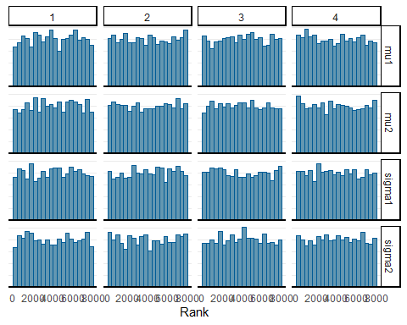

m.conn %>%  
 as_draws() %>%  
 subset_draws(variable = c("mu1", "mu2", "sigma1", "sigma2")) %>%  
 summarize_draws() %>%  
 knitr::kable()

| variable | mean | median | sd | mad | q5 | q95 | rhat | ess_bulk | ess_tail |
| --- | --- | --- | --- | --- | --- | --- | --- | --- | --- |
| mu1 | 3.8430574 | 3.8429508 | 0.0469256 | 0.0457713 | 3.7654191 | 3.9215139 | 1.000405 | 9979.452 | 6239.443 |
| mu2 | 3.7802845 | 3.7798784 | 0.0464829 | 0.0462095 | 3.7046060 | 3.8573242 | 1.000036 | 9826.342 | 6514.629 |
| sigma1 | 0.5557392 | 0.5544471 | 0.0326691 | 0.0320328 | 0.5048525 | 0.6116920 | 1.000070 | 9121.289 | 5569.636 |
| sigma2 | 0.5506291 | 0.5489496 | 0.0330004 | 0.0322975 | 0.5003631 | 0.6073617 | 1.000624 | 10344.865 | 6463.065 |

mcmc_rank_hist(m.conn, pars = c("mu1", "mu2", "sigma1", "sigma2"))

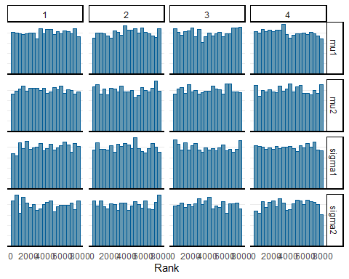

m.dist %>%  
 as_draws() %>%  
 subset_draws(variable = c("mu1", "mu2", "sigma1", "sigma2")) %>%  
 summarize_draws() %>%  
 knitr::kable()

| variable | mean | median | sd | mad | q5 | q95 | rhat | ess_bulk | ess_tail |
| --- | --- | --- | --- | --- | --- | --- | --- | --- | --- |
| mu1 | 3.6101415 | 3.6101170 | 0.0390757 | 0.0392591 | 3.5470783 | 3.6750709 | 0.9999150 | 8917.722 | 6073.976 |
| mu2 | 3.5320689 | 3.5317296 | 0.0447203 | 0.0449557 | 3.4594890 | 3.6051741 | 1.0006984 | 9339.992 | 6376.772 |
| sigma1 | 0.4569586 | 0.4553705 | 0.0278949 | 0.0277808 | 0.4144171 | 0.5052760 | 0.9998198 | 9940.592 | 6114.560 |
| sigma2 | 0.5204312 | 0.5188662 | 0.0310412 | 0.0306295 | 0.4728284 | 0.5737163 | 0.9998475 | 9206.605 | 6301.722 |

mcmc_rank_hist(m.dist, pars = c("mu1", "mu2", "sigma1", "sigma2"))

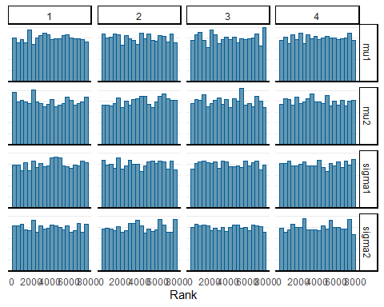

m.rel %>%  
 as_draws() %>%  
 subset_draws(variable = c("mu1", "mu2", "sigma1", "sigma2")) %>%  
 summarize_draws() %>%  
 knitr::kable()

| variable | mean | median | sd | mad | q5 | q95 | rhat | ess_bulk | ess_tail |
| --- | --- | --- | --- | --- | --- | --- | --- | --- | --- |
| mu1 | 3.6472633 | 3.6472525 | 0.0485154 | 0.0478558 | 3.5675065 | 3.7275468 | 1.001161 | 8520.292 | 6423.841 |
| mu2 | 3.5492926 | 3.5489831 | 0.0443474 | 0.0445801 | 3.4763958 | 3.6218185 | 1.000738 | 8790.563 | 5861.538 |
| sigma1 | 0.5709442 | 0.5695976 | 0.0353045 | 0.0353547 | 0.5161341 | 0.6308926 | 1.000152 | 8267.167 | 5871.464 |
| sigma2 | 0.5236025 | 0.5221812 | 0.0322051 | 0.0318594 | 0.4729996 | 0.5792244 | 1.000783 | 8575.671 | 6327.083 |

mcmc_rank_hist(m.rel, pars = c("mu1", "mu2", "sigma1", "sigma2"))

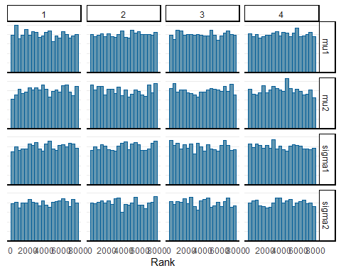

The following table shows the posterior distributions of $μ_{1}$, $μ_{2}$, $σ_{1}$, $σ_{2}$, and $μ_{2}−μ_{1}$.

summ_m.vivid <- as_draws_df(m.vivid) %>%  
 subset_draws(variable = c("mu1", "mu2", "sigma1", "sigma2")) %>%  
 mutate_variables(`mu2 - mu1` = mu2 - mu1) %>%  
 summarise_draws()  
knitr::kable(summ_m.vivid, digits = 2)

| variable | mean | median | sd | mad | q5 | q95 | rhat | ess_bulk | ess_tail |
| --- | --- | --- | --- | --- | --- | --- | --- | --- | --- |
| mu1 | 3.39 | 3.39 | 0.04 | 0.03 | 3.33 | 3.45 | 1 | 9188.01 | 6280.98 |
| mu2 | 3.38 | 3.38 | 0.04 | 0.04 | 3.31 | 3.45 | 1 | 9566.94 | 6243.26 |
| sigma1 | 0.42 | 0.42 | 0.03 | 0.03 | 0.38 | 0.47 | 1 | 9100.62 | 5994.97 |
| sigma2 | 0.52 | 0.51 | 0.03 | 0.03 | 0.47 | 0.57 | 1 | 9074.30 | 5858.81 |
| mu2 - mu1 | -0.01 | -0.01 | 0.06 | 0.06 | -0.10 | 0.09 | 1 | 9348.93 | 5756.37 |

summ_m.conn <- as_draws_df(m.conn) %>%  
 subset_draws(variable = c("mu1", "mu2", "sigma1", "sigma2")) %>%  
 mutate_variables(`mu2 - mu1` = mu2 - mu1) %>%  
 summarise_draws()  
knitr::kable(summ_m.conn, digits = 2)

| variable | mean | median | sd | mad | q5 | q95 | rhat | ess_bulk | ess_tail |
| --- | --- | --- | --- | --- | --- | --- | --- | --- | --- |
| mu1 | 3.84 | 3.84 | 0.05 | 0.05 | 3.77 | 3.92 | 1 | 9979.45 | 6239.44 |
| mu2 | 3.78 | 3.78 | 0.05 | 0.05 | 3.70 | 3.86 | 1 | 9826.34 | 6514.63 |
| sigma1 | 0.56 | 0.55 | 0.03 | 0.03 | 0.50 | 0.61 | 1 | 9121.29 | 5569.64 |
| sigma2 | 0.55 | 0.55 | 0.03 | 0.03 | 0.50 | 0.61 | 1 | 10344.87 | 6463.07 |
| mu2 - mu1 | -0.06 | -0.06 | 0.07 | 0.07 | -0.17 | 0.05 | 1 | 10142.12 | 5900.34 |

summ_m.dist <- as_draws_df(m.dist) %>%  
 subset_draws(variable = c("mu1", "mu2", "sigma1", "sigma2")) %>%  
 mutate_variables(`mu2 - mu1` = mu2 - mu1) %>%  
 summarise_draws()  
knitr::kable(summ_m.dist, digits = 2)

| variable | mean | median | sd | mad | q5 | q95 | rhat | ess_bulk | ess_tail |
| --- | --- | --- | --- | --- | --- | --- | --- | --- | --- |
| mu1 | 3.61 | 3.61 | 0.04 | 0.04 | 3.55 | 3.68 | 1 | 8917.72 | 6073.98 |
| mu2 | 3.53 | 3.53 | 0.04 | 0.04 | 3.46 | 3.61 | 1 | 9339.99 | 6376.77 |
| sigma1 | 0.46 | 0.46 | 0.03 | 0.03 | 0.41 | 0.51 | 1 | 9940.59 | 6114.56 |
| sigma2 | 0.52 | 0.52 | 0.03 | 0.03 | 0.47 | 0.57 | 1 | 9206.61 | 6301.72 |
| mu2 - mu1 | -0.08 | -0.08 | 0.06 | 0.06 | -0.18 | 0.02 | 1 | 9320.43 | 5794.30 |

summ_m.rel <- as_draws_df(m.rel) %>%  
 subset_draws(variable = c("mu1", "mu2", "sigma1", "sigma2")) %>%  
 mutate_variables(`mu2 - mu1` = mu2 - mu1) %>%  
 summarise_draws()  
knitr::kable(summ_m.rel, digits = 2)

| variable | mean | median | sd | mad | q5 | q95 | rhat | ess_bulk | ess_tail |
| --- | --- | --- | --- | --- | --- | --- | --- | --- | --- |
| mu1 | 3.65 | 3.65 | 0.05 | 0.05 | 3.57 | 3.73 | 1 | 8520.29 | 6423.84 |
| mu2 | 3.55 | 3.55 | 0.04 | 0.04 | 3.48 | 3.62 | 1 | 8790.56 | 5861.54 |
| sigma1 | 0.57 | 0.57 | 0.04 | 0.04 | 0.52 | 0.63 | 1 | 8267.17 | 5871.46 |
| sigma2 | 0.52 | 0.52 | 0.03 | 0.03 | 0.47 | 0.58 | 1 | 8575.67 | 6327.08 |
| mu2 - mu1 | -0.10 | -0.10 | 0.06 | 0.06 | -0.20 | 0.01 | 1 | 8700.72 | 6632.65 |

The analysis showed that on average, the two conditions did not differ significantly in how vividly they imagined the future self, with a posterior mean of -0.01. However, the stability condition did perceive the future self as slightly more connected -0.06, temporally closer -0.08, and more relevant -0.1.

#Exploratory Analysis

m.plan %>%  
 as_draws() %>%  
 subset_draws(variable = c("mu1", "mu2", "sigma1", "sigma2")) %>%  
 summarize_draws() %>%  
 knitr::kable()

| variable | mean | median | sd | mad | q5 | q95 | rhat | ess_bulk | ess_tail |
| --- | --- | --- | --- | --- | --- | --- | --- | --- | --- |
| mu1 | 2.978599 | 2.979803 | 0.0851421 | 0.0845906 | 2.8364060 | 3.115407 | 1.0008131 | 9278.354 | 6183.856 |
| mu2 | 2.680128 | 2.680064 | 0.0797413 | 0.0788570 | 2.5491928 | 2.810171 | 1.0002865 | 8634.654 | 6229.804 |
| sigma1 | 1.007615 | 1.004141 | 0.0610257 | 0.0605666 | 0.9122734 | 1.113513 | 1.0011306 | 9329.413 | 6425.321 |
| sigma2 | 0.940976 | 0.937857 | 0.0567835 | 0.0562063 | 0.8528941 | 1.038196 | 0.9999324 | 9402.098 | 6197.477 |

mcmc_rank_hist(m.plan, pars = c("mu1", "mu2", "sigma1", "sigma2"))

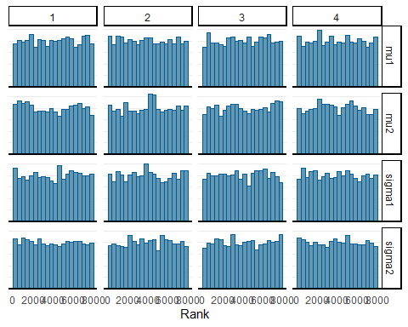

m.prep %>%  
 as_draws() %>%  
 subset_draws(variable = c("mu1", "mu2", "sigma1", "sigma2")) %>%  
 summarize_draws() %>%  
 knitr::kable()

| variable | mean | median | sd | mad | q5 | q95 | rhat | ess_bulk | ess_tail |
| --- | --- | --- | --- | --- | --- | --- | --- | --- | --- |
| mu1 | 4.7330846 | 4.7324383 | 0.0716881 | 0.0721471 | 4.6158355 | 4.8514568 | 1.0005302 | 9441.370 | 6275.094 |
| mu2 | 4.8589164 | 4.8588309 | 0.0720077 | 0.0727882 | 4.7402060 | 4.9757373 | 0.9999019 | 8958.907 | 5897.700 |
| sigma1 | 0.8501291 | 0.8475546 | 0.0515213 | 0.0518680 | 0.7710154 | 0.9382998 | 1.0007176 | 9285.063 | 6417.555 |
| sigma2 | 0.8500916 | 0.8471560 | 0.0508358 | 0.0501597 | 0.7710204 | 0.9398488 | 1.0007928 | 9644.499 | 5887.484 |

mcmc_rank_hist(m.prep, pars = c("mu1", "mu2", "sigma1", "sigma2"))

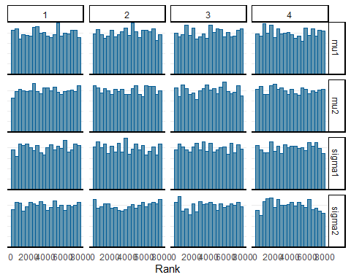

summ_m.plan <- as_draws_df(m.plan) %>%  
 subset_draws(variable = c("mu1", "mu2", "sigma1", "sigma2")) %>%  
 mutate_variables(`mu2 - mu1` = mu2 - mu1) %>%  
 summarise_draws()  
knitr::kable(summ_m.plan, digits = 2)

| variable | mean | median | sd | mad | q5 | q95 | rhat | ess_bulk | ess_tail |
| --- | --- | --- | --- | --- | --- | --- | --- | --- | --- |
| mu1 | 2.98 | 2.98 | 0.09 | 0.08 | 2.84 | 3.12 | 1 | 9278.35 | 6183.86 |
| mu2 | 2.68 | 2.68 | 0.08 | 0.08 | 2.55 | 2.81 | 1 | 8634.65 | 6229.80 |
| sigma1 | 1.01 | 1.00 | 0.06 | 0.06 | 0.91 | 1.11 | 1 | 9329.41 | 6425.32 |
| sigma2 | 0.94 | 0.94 | 0.06 | 0.06 | 0.85 | 1.04 | 1 | 9402.10 | 6197.48 |
| mu2 - mu1 | -0.30 | -0.30 | 0.12 | 0.12 | -0.49 | -0.10 | 1 | 8791.82 | 6353.38 |

summ_m.prep <- as_draws_df(m.prep) %>%  
 subset_draws(variable = c("mu1", "mu2", "sigma1", "sigma2")) %>%  
 mutate_variables(`mu2 - mu1` = mu2 - mu1) %>%  
 summarise_draws()  
knitr::kable(summ_m.prep, digits = 2)

| variable | mean | median | sd | mad | q5 | q95 | rhat | ess_bulk | ess_tail |
| --- | --- | --- | --- | --- | --- | --- | --- | --- | --- |
| mu1 | 4.73 | 4.73 | 0.07 | 0.07 | 4.62 | 4.85 | 1 | 9441.37 | 6275.09 |
| mu2 | 4.86 | 4.86 | 0.07 | 0.07 | 4.74 | 4.98 | 1 | 8958.91 | 5897.70 |
| sigma1 | 0.85 | 0.85 | 0.05 | 0.05 | 0.77 | 0.94 | 1 | 9285.06 | 6417.55 |
| sigma2 | 0.85 | 0.85 | 0.05 | 0.05 | 0.77 | 0.94 | 1 | 9644.50 | 5887.48 |
| mu2 - mu1 | 0.13 | 0.13 | 0.10 | 0.10 | -0.04 | 0.29 | 1 | 9428.65 | 5444.99 |

rquery.cormat(data[c("VIVD","CONNECT","DIST","RELEVANCE", "PLAN", "PREP")], type="flatten")

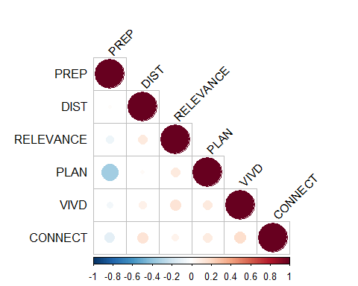

## $r  
## row column cor p  
## 1 PREP DIST 0.013 8.3e-01  
## 2 PREP RELEVANCE -0.080 1.8e-01  
## 3 DIST RELEVANCE 0.110 7.1e-02  
## 4 PREP PLAN -0.340 3.5e-09  
## 5 DIST PLAN 0.025 6.8e-01  
## 6 RELEVANCE PLAN 0.110 7.4e-02  
## 7 PREP VIVD -0.053 3.8e-01  
## 8 DIST VIVD 0.075 2.1e-01  
## 9 RELEVANCE VIVD 0.140 2.0e-02  
## 10 PLAN VIVD 0.110 6.0e-02  
## 11 PREP CONNECT -0.120 5.3e-02  
## 12 DIST CONNECT 0.140 2.3e-02  
## 13 RELEVANCE CONNECT 0.064 2.9e-01  
## 14 PLAN CONNECT 0.100 9.5e-02  
## 15 VIVD CONNECT 0.170 3.9e-03  
##   
## $p  
## NULL  
##   
## $sym  
## NULL

model.full1 = ' Vivid =~ CG_1 + CGR_2  
 Connect =~ CG_3 + CG_4R  
 Distance =~ CG_5 + CG_6R  
 Relevance =~ CG_7R + CG_8  
  
Vivid ~ COND  
Connect ~ COND  
Distance ~ COND  
Relevance ~ COND   
'  
  
model.full1.fit <- blavaan(model.full1, data = data, auto.var=TRUE, auto.fix.first=TRUE, auto.cov.lv.x=TRUE)

## Computing posterior predictives...

summary(model.full1.fit, fit.measures=TRUE, standardized=TRUE)

## blavaan (0.4-1) results of 1000 samples after 500 adapt/burnin iterations  
##   
## Number of observations 280  
##   
## Number of missing patterns 1  
##   
## Statistic MargLogLik PPP  
## Value -4348.932 0.000  
##   
## Latent Variables:  
## Estimate Post.SD pi.lower pi.upper Std.lv Std.all  
## Vivid =~   
## CG_1 1.000 1.328 0.605  
## CGR_2 0.594 0.027 0.542 0.647 0.789 0.467  
## Connect =~   
## CG_3 1.000 1.737 0.804  
## CG_4R 0.685 0.025 0.637 0.734 1.190 0.614  
## Distance =~   
## CG_5 1.000 1.199 0.616  
## CG_6R 0.954 0.039 0.882 1.032 1.143 0.548  
## Relevance =~   
## CG_7R 1.000 0.941 0.595  
## CG_8 1.977 0.076 1.836 2.130 1.859 0.795  
## Rhat Prior   
##   
##   
## 1.000 normal(0,10)  
##   
##   
## 1.000 normal(0,10)  
##   
##   
## 1.000 normal(0,10)  
##   
##   
## 1.000 normal(0,10)  
##   
## Regressions:  
## Estimate Post.SD pi.lower pi.upper Std.lv Std.all  
## Vivid ~   
## COND 2.544 0.069 2.408 2.678 1.916 0.958  
## Connect ~   
## COND 2.701 0.065 2.571 2.828 1.555 0.777  
## Distance ~   
## COND 2.180 0.061 2.057 2.300 1.818 0.909  
## Relevance ~   
## COND 1.441 0.054 1.336 1.547 1.532 0.766  
## Rhat Prior   
##   
## 1.000 normal(0,10)  
##   
## 1.000 normal(0,10)  
##   
## 0.999 normal(0,10)  
##   
## 0.999 normal(0,10)  
##   
## Intercepts:  
## Estimate Post.SD pi.lower pi.upper Std.lv Std.all  
## .CG_1 0.000 0.000 0.000  
## .CGR_2 0.000 0.000 0.000  
## .CG_3 0.000 0.000 0.000  
## .CG_4R 0.000 0.000 0.000  
## .CG_5 0.000 0.000 0.000  
## .CG_6R 0.000 0.000 0.000  
## .CG_7R 0.000 0.000 0.000  
## .CG_8 0.000 0.000 0.000  
## .Vivid 0.000 0.000 0.000  
## .Connect 0.000 0.000 0.000  
## .Distance 0.000 0.000 0.000  
## .Relevance 0.000 0.000 0.000  
## Rhat Prior   
##   
##   
##   
##   
##   
##   
##   
##   
##   
##   
##   
##   
##   
## Variances:  
## Estimate Post.SD pi.lower pi.upper Std.lv Std.all  
## .CG_1 3.045 0.307 2.445 3.655 3.045 0.633  
## .CGR_2 2.229 0.200 1.862 2.650 2.229 0.782  
## .CG_3 1.656 0.293 1.114 2.258 1.656 0.354  
## .CG_4R 2.335 0.229 1.913 2.808 2.335 0.623  
## .CG_5 2.347 0.269 1.849 2.898 2.347 0.620  
## .CG_6R 3.049 0.299 2.466 3.652 3.049 0.700  
## .CG_7R 1.616 0.160 1.321 1.962 1.616 0.646  
## .CG_8 2.017 0.353 1.364 2.743 2.017 0.368  
## .Vivid 0.145 0.153 0.000 0.542 0.082 0.082  
## .Connect 1.194 0.275 0.685 1.760 0.396 0.396  
## .Distance 0.249 0.180 0.002 0.634 0.173 0.173  
## .Relevance 0.365 0.084 0.211 0.539 0.413 0.413  
## Rhat Prior   
## 1.001 gamma(1,.5)[sd]  
## 1.000 gamma(1,.5)[sd]  
## 1.002 gamma(1,.5)[sd]  
## 1.000 gamma(1,.5)[sd]  
## 1.002 gamma(1,.5)[sd]  
## 1.001 gamma(1,.5)[sd]  
## 1.000 gamma(1,.5)[sd]  
## 1.001 gamma(1,.5)[sd]  
## 1.001 gamma(1,.5)[sd]  
## 1.001 gamma(1,.5)[sd]  
## 1.004 gamma(1,.5)[sd]  
## 1.000 gamma(1,.5)[sd]

coef(model.full1.fit)

## Vivid=~CGR_2 Connect=~CG_4R Distance=~CG_6R   
## 0.594 0.685 0.954   
## Relevance=~CG_8 Vivid~COND Connect~COND   
## 1.977 2.544 2.701   
## Distance~COND Relevance~COND CG_1~~CG_1   
## 2.180 1.441 3.045   
## CGR_2~~CGR_2 CG_3~~CG_3 CG_4R~~CG_4R   
## 2.229 1.656 2.335   
## CG_5~~CG_5 CG_6R~~CG_6R CG_7R~~CG_7R   
## 2.347 3.049 1.616   
## CG_8~~CG_8 Vivid~~Vivid Connect~~Connect   
## 2.017 0.145 1.194   
## Distance~~Distance Relevance~~Relevance   
## 0.249 0.365

ML <- blavFitIndices(model.full1.fit)  
summary(ML)

##   
## Posterior summary statistics and highest posterior density (HPD) 90% credible intervals for devm-based fit indices:  
##   
## EAP Median MAP SD lower upper  
## BRMSEA 0.476 0.476 0.476 0.001 0.475 0.477  
## BGammaHat 0.341 0.341 0.342 0.001 0.340 0.342  
## adjBGammaHat 0.072 0.072 0.072 0.001 0.071 0.073  
## BMc 0.013 0.013 0.013 0.000 0.013 0.013

semPaths(model.full1.fit, what="est", edge.label.cex = .9, fade = FALSE,intercepts = FALSE, residuals = FALSE, layoutSplit = T, layout = 'tree2', nCharNodes = 0, sizeMan = 7 )

